

**Serial Peripheral Interface**

**Advanced Logic Design**

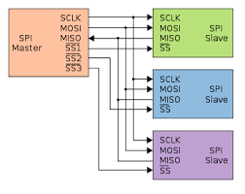

**Team Members:**

1. **Ahmed Alaa El-Sayed Arabi Zidan (SEC: 1, BN:6)**
2. **Ahmed Atta Abdallah Abdelhay (SEC:1, BN:5)**
3. **Menatalh Hossamalden Abdrabo Said (SEC:2, BN:27)**
4. **Sarah Mohamed Hossam Hassan Sayed (SEC:1, BN:29)**

**Supervised by:**

* **Dr. Ihab Talkhan**
* **Eng. Mustafa Mahmoud**
* **Eng. Yahya Zakaria**

**Part I: Master Module**

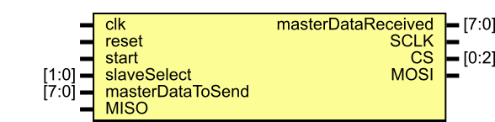

Figure 1: Master Prototype

**A. Ports:**

|  |  |  |
| --- | --- | --- |
| **Port Name** | **Type / Size** | **Description** |
| clk | Input | The synchronous clock generated from the Microcontroller feeding the master of SPI. |
| reset | Input | Resets the Register’s Data to 0  (Asynchronous reset). |
| start | Input | The bit which trigger the transmission and receiving process. |
| slaveSelect | Input [1:0] | The number of the slave to be connected to. |
| masterDataToSend | Input [7:0] | The 8-bits data we put in the Register to be sent in the transmission process. |
| MISO | Input | The bit received by the master from slave at each clock pulse. |
| masterDataRecieved | Output reg [7:0] | The 8-bits data which The Slave Receives at the end of receiving process. |
| SCLK | output | The Synchronous clock of The Master. |
| CS | Output [0:2] | Enable bit of The Transmission (Active-Low). |
| MOSI | Output reg | The bit transmitted to the slave from the master at each clock pulse. |

**B. Local and Unported Signals:**

|  |  |  |
| --- | --- | --- |
| **Name** | **Type / Size** | **Description** |
| counter | integer | A counter that counts the number of bets |
| flag | reg | A bit raised to high when the transmission and receiving process are terminated. |
| buffer | Reg [7:0] | - The Register inside the master  - A normal shift Register with MISO as its IL and MOSI as its IR. |

**C. Processes and The Data Flow:**

1. At the falling edge of SCLK (At the beginning):

- The master read the slaveSelect.

- Sent the CS bit for each slave (in the same time)

- Initialize the masterDataRecieved by unknowns.

- Initialize the buffer by masterDataToSend.

- Initialize the counter by 1

- Initialize the flag by zero

1. At the rising edge of SCLK (shifting process):

- Shifting the LSB in the buffer into the MISO.

1. At the falling edge of SCLK (Sampling process):

- Shifting the MOSI bit into the Register from the left.

- Updating the SlaveDataReceived to contain the same bits as the Register.

4. At the raising edge of flag:

- Both transmission and receiving process are terminated.

**PART II: Self-Checking Testbench for the Master Module**

**A. Local and Unported Signals:**

|  |  |  |
| --- | --- | --- |
| **Name** | **Type** | **Description** |
| **CLK** | **reg** | **Input to Master** |
| **Start** | **reg** | **Input to Master** |
| **Slave Select** | **reg [1:0]** | **Input to Master** |
| **reset** | **reg** | **Input to Master** |
| **MISO** | **reg** | **Input to Master** |
| **SCLK** | **wire** | **Output from Master** |
| **CS** | **wire [0:2]** | **Output from Master** |
| **MOSI** | **wire** | **Output from Master** |
| **masterDataToSend** | **reg [7:0]** | **Input to Master** |
| **masterDataReceived** | **wire [7:0]** | **output from master module** |
| **ExpectedSlaveDataToReceive** | **reg [7:0]** | **The 8-bits data which the Slave is expected to receive at the end of transmission** |
| **testcase_SlaveDataToSend** | **wire [7:0] array [1:4]** | **The 4-element array of 8-bit data which is expected to be sent by Master in transmission** |
| **testcase_MasterDataToSend** | **wire [7:0] array [1:4]** | **The 4-element array of 8-bit data which is an input to Master in transmission (masterDataToSend)** |

**B. Processes and The Data Flow:**

1. Initializing Local and unported signals:

- Initialize start with 0 then 1 (triggering the start signal to start transmission).

- Initialize input data loaded to Master and expected data to receive.

- Initialize slave select.

1. At the rising edge of CLK (mimicking shifting process of Slave):

- Setting MISO with bit of testcase_SlaveDataToSend.

- Increasing i by 1.

1. At the falling edge of CLK (sampling process):

- Updating the ExpectedSlaveDataToReceive to contain all the bits shifted by Master and sampled by Slave.

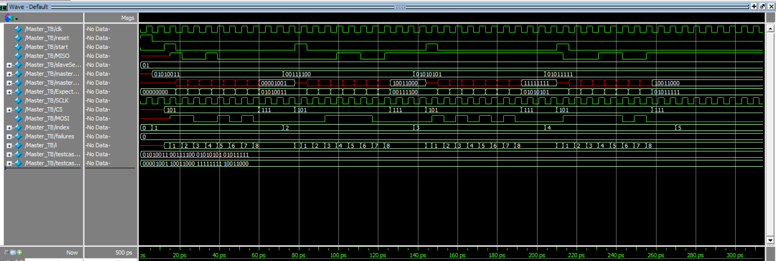**C. Wave of Master simulation**

Figure 2 : Wave form

**D- Transcript**

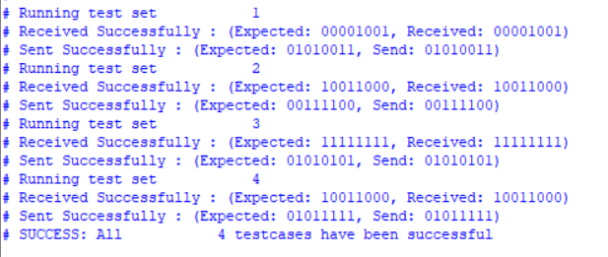

Figure 3 : Transcript

**Part III: Slave Module**

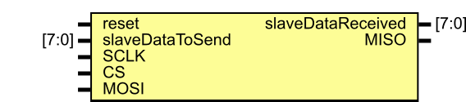

Figure 4 Slave

**A. Ports:**

|  |  |  |
| --- | --- | --- |
| **Port Name** | **Type / Size** | **Description** |
| reset | Input | Resets the Register’s Data to 0  (Asynchronous reset). |
| slaveDataToSend | Input [7:0] | The 8-bits data we put in the Register to send in the transmission process. |
| slaveDataReceived | output reg [7:0] | The 8-bits data which The Slave Receives at the end of transmission. |
| SCLK | Input | The Synchronous clock of The Master. |
| CS | Input | Enable bit of The Transmission (Active-Low). |
| MOSI | Input | The bit received by slave from the master at each clock pulse. |
| MISO | Output reg | The bit transmitted to the master from slave at each clock pulse. |

**B. Local and Unported Signals:**

|  |  |  |
| --- | --- | --- |
| **Name** | **Type / Size** | **Description** |
| Reg Data | reg [7:0] | - The Register inside The Slave  - A normal shift Register with MOSI as its IL and MISO as its IR. |

**C. Processes and The Data Flow:**

1. At the falling edge of CS:

- Indicates the start of the transmission.

- The Slave loads the data that will be transmitted into the register.

1. At the rising edge of CS:

- Indicates the end of the transmission

- Setting MISO to high-z.

1. At the rising edge of SCLK (shifting process):

- Shifting the LSB in the register into the MISO.

1. At the falling edge of SCLK (Sampling process):

- Shifting the MOSI bit into the Register from the left.

- Updating the SlaveDataReceived to contain the same bits as the Register.

**Part IV: Self-Checking Testbench for the Slave Module**

**A. Local and Unported Signals:**

|  |  |  |
| --- | --- | --- |
| **Name** | **Type** | **Description** |
| reset | reg | Input to Slave |
| SCLK | reg | Input to Slave |
| CS | reg | Input to Slave |
| MOSI | reg | Input to Slave |
| MISO | wire | output from Slave |
| slaveDataToSend | reg [7:0] | Input to Slave |
| slaveSataReceived | wire [7:0] | output from slave module |
| ExpectedMasterDataToReceive | reg [7:0] | The 8-bits data which the Master is expected to receive at the end of transmission |
| testcase_MasterDataToSend | wire [7:0] array [1:4] | The 4-element array of 8-bit data which is expected to be sent by Master in transmission |
| testcase_SlaveDataToSend | wire [7:0] array [1:4] | The 4-element array of 8-bit data which is an input to Slave in transmission (slaveDataToSend) |

**B. Processes and The Data Flow:**

1. Initializing Local and unported signals:

- Initialize CS with 1 then 0 (triggering falling edge of CS).

- Initialize input data loaded to Slave.

1. Set CS =1:

- Triggering rising edge of CS.

- Checking if data received and sent by Slave is as Expected and display an indicative message.

1. At the rising edge of SCLK (mimicking the shifting process of Master):

- Setting MOSI with bit of testcase_MasterDataToSend.

- Increase i by 1.

1. At the falling edge of SCLK (sampling process):

- Updating the ExpectedMasterDataToReceive to contain all the bits shifted by Slave and sampled by Master.

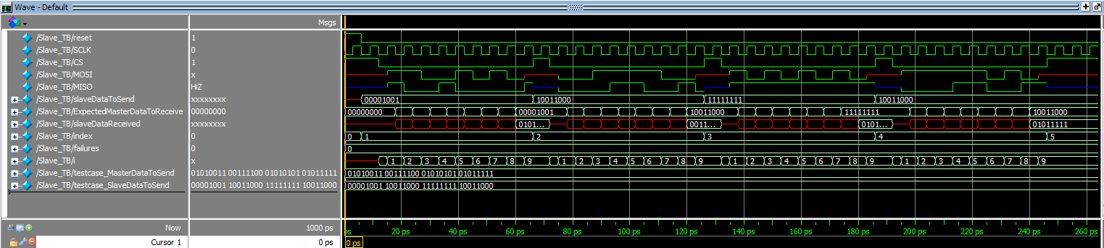**C. Simulation of Slave:**

Figure 5: Wave form

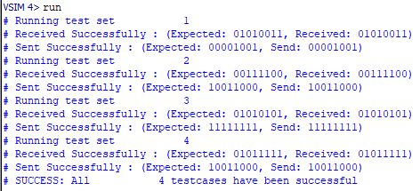  
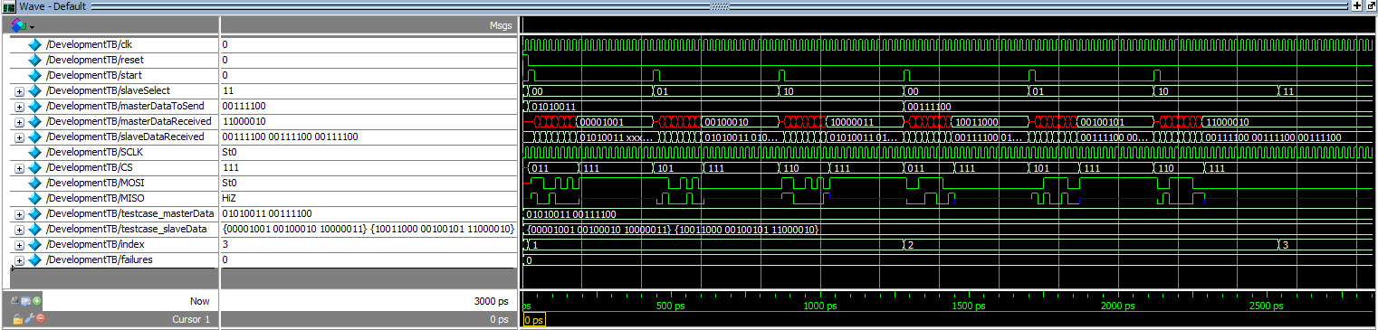**D. Simulation of Development Testbench:**

Figure 6: Displayed Messages

Figure 7 : Development Wave Form

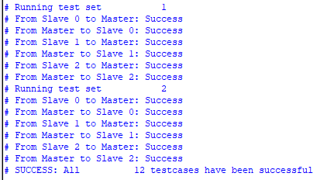

Figure 8 : Development Displayed Message